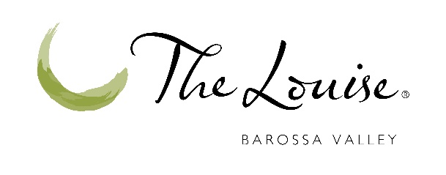

July 19, 2021
Baillie Lodges Welcomes The Louise to its Growing Collection
The Louise, a preeminent luxury lodge in South Australia’s Barossa Valley, is set to join the growing Baillie Lodges family in September 2021. Nestled in the heart of the Barossa’s world-renowned wine region, The Louise is an acclaimed luxury culinary destination, and known across the Australian tourism industry as the birthplace of Luxury Lodges of Australia.
Some 16 years ago, owners Jim and Helen Carreker embarked on redeveloping an existing country motel into a 15-suite luxury lodge set in the Barossa’s gently rolling hills and offering sun-dappled views of the region’s trademark vineyards. Essential to the Carrekers’ vision was a genuine, food- and wine-paired dining experience showcasing the Barossa community’s most exceptional wines – from world-renowned wine houses including Penfolds, Henschke and Seppeltsfield to boutique cellar doors like Izway and David Franz.
For Baillie Lodges, the acquisition of The Louise is a natural fit within its brand portfolio, representing the culmination of many years of industry association, collaboration, and shared friendship. The Louise’s loyal guests and its team of dedicated staff can expect a seamless transfer of ownership, with all staff remaining at the lodge under the leadership of esteemed General Manager, Kylie Mansfield.
Baillie Lodges Chief Operating Officer Craig Bradbery has extended a comprehensive welcome to the employee team of The Louise as they join the collection. “It’s our custom to welcome all employees at each of our new properties into the Baillie Lodges family, offering opportunities for further career advancement and exposure to tourism and hospitality industry best practices,”
Mr Bradbery said.
Baillie Lodges Founder James Baillie said he felt very privileged to be the custodian of a property like The Louise. “We’re delighted that Jim and Helen have entrusted us to continue their legacy and vision for creating exceptional culinary tourism in the Barossa,” Mr Baillie said.
“In 2009, my wife Hayley and I stayed at The Louise at the invitation of Jim and Helen to participate in the genesis planning for the Luxury Lodges of Australia cooperative. In the decade since, we have welcomed domestic and international guests travelling to South Australia whose itineraries included stays at both The Louise and Southern Ocean Lodge. Our teams are already great mates, and our respective lodges’ ‘hospitality DNA’ is profoundly matched. We have always considered that a marriage of The Louise’s culinary excellence with our growing portfolio of luxury lodges would be an ideal match,” Mr Baillie said.
The Louise Owner and Managing Director Jim Carreker said he couldn’t have imagined a better fit for the property. “We’ve really had our hearts and souls invested in The Louise and in the Barossa community over these past 16 years and it’s been a joy for us. We recognise the future potential for The Louise and our professional hospitality team under the Baillie Lodges brand and feel confident that our commitment to extraordinary guest experiences will be upheld as the Barossa enters a new era in luxury travel,” Mr Carreker said.
“In 2005, Helen and I had a vision to help develop the global appeal for culinary stays in the Barossa to match that of other iconic wine regions such as Napa, Bordeaux and Tuscany. That goal is largely achieved, and it’s now time for The Louise to join an internationally significant brand with all the resources to further develop both the reputation and the facilities of this very unique property,” he said.
“This acquisition will be vitally important to the economy of the Barossa and South Australia.
Our personal mission in the hospitality industry here will soon be complete, and we look forward to returning frequently as guests at The Louise to share in the growth of brand Barossa as a drawcard for international premium visitors to Australia.”
Baillie Lodges’ growing portfolio of upscale lodges also includes Longitude 131° at
Uluru-Kata Tjuta, Capella Lodge on Lord Howe Island and Tropical North Queensland luxury bolt-hole Silky Oaks Lodge in the Daintree, which is currently under renovation ahead of reopening in spring this year. The company’s flagship property, Southern Ocean Lodge on Kangaroo Island, was destroyed in bushfires in 2020, with rebuilding plans underway. The Baillie Lodges collection extends oversees with New Zealand’s iconic Huka Lodge and Vancouver Island’s Clayoquot Wilderness Lodge.
Image for download here:
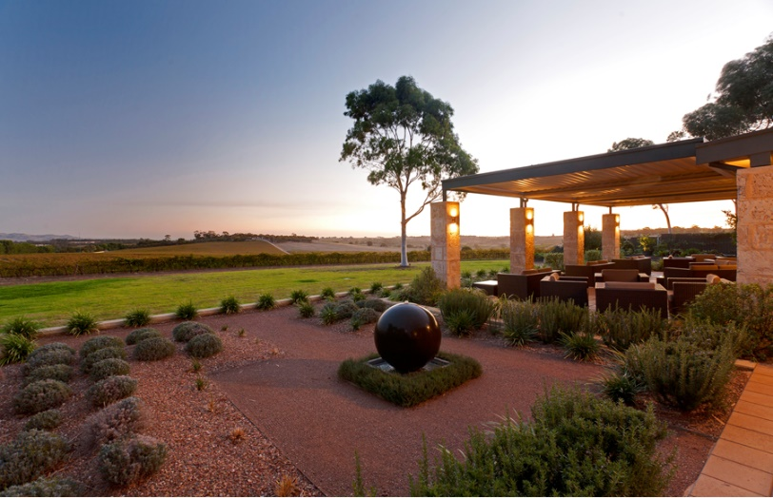

Editors’ Notes: Baillie Lodges is an intimate portfolio of luxury lodges setting new benchmarks for premium experiential travel. Set in exclusive locations of unique natural or cultural significance, the boutique properties appeal to the discerning global traveller seeking a remarkable experience. The Australia-based collection was founded in 2003 by James and Hayley Baillie and includes Longitude 131° at Uluru-Kata Tjuta, Capella Lodge on Lord Howe Island and Silky Oaks Lodge at the Daintree Rainforest. Flagship property Southern Ocean Lodge on Kangaroo Island was destroyed in the 2020 bushfires and its rebuild is currently in planning. In 2019, an affiliate of KSL Capital Partners, a global private equity firm specialising in travel and leisure enterprises, acquired Baillie Lodges with the aim to further expand the unique collection of luxury lodges. Most recently, Clayoquot Wilderness Lodge on Canada’s Vancouver Island and New Zealand’s Huka Lodge joined the Baillie Lodges portfolio, marking the collection’s foray into international waters. For more information, please visit baillielodges.com.au.
Baillie Lodges’ Australian properties are honoured as members of Luxury Lodges of Australia.

Media Contacts:
The Louise Jim Carreker jim@thelouise.com.au
Emma Welling emma@thelouise.com.au
Baillie Lodges Sarah Shields sarah@baillielodges.com.au

